---

Step-by-Step Guide to Set Up Docker for Windows and Run a Dockerized React Application

Download Docker for Windows:
- Go to the Docker website (https://www.docker.com/products/docker-desktop) and download Docker Desktop for Windows.
- Click on the download button and follow the installation instructions provided by the installer.

Install Docker:
- Once the download is complete, run the installer.
- Follow the on-screen instructions to install Docker on your Windows machine.
- You may need to restart your computer after the installation is complete.

Create a Docker Account:
- After installing Docker, open the Docker Desktop application.
- If you don't already have a Docker account, you will be prompted to create one.
- Follow the instructions to create a Docker account.

Install Node JS
Install Node JS from Node.js — Download (nodejs.org)

Run Docker Desktop:
- Open the Docker Desktop application from your desktop or start menu.
- Log in with your Docker account credentials if prompted.

Open Visual Studio Code:
- If you haven't already installed Visual Studio Code, you can download it from https://code.visualstudio.com/.
- Once installed, open Visual Studio Code.

Open Your Project Folder that is named as app:
- Navigate to your project folder where your React application named app is located.
- Right-click on the folder and select "Open with Code" to open the folder in Visual Studio Code.

Open Terminal in Visual Studio Code
- Once your project folder is open in Visual Studio Code, open the integrated terminal by going to View > Terminal or pressing Ctrl+`.
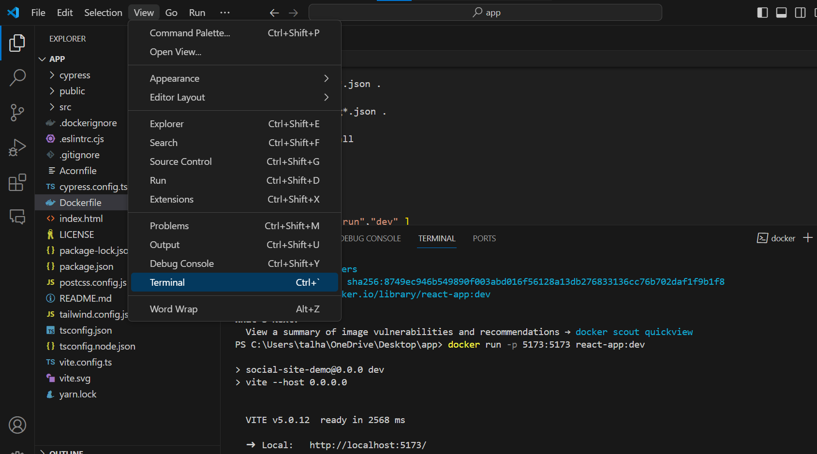

Run Docker Command:
- In the terminal, paste the following command:
```
One by one. Don’t ignore dot written at last
docker build -t react-app:dev .
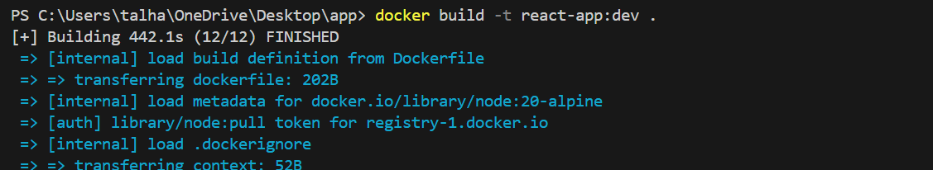
docker run -p 5173:5173 react-app:dev
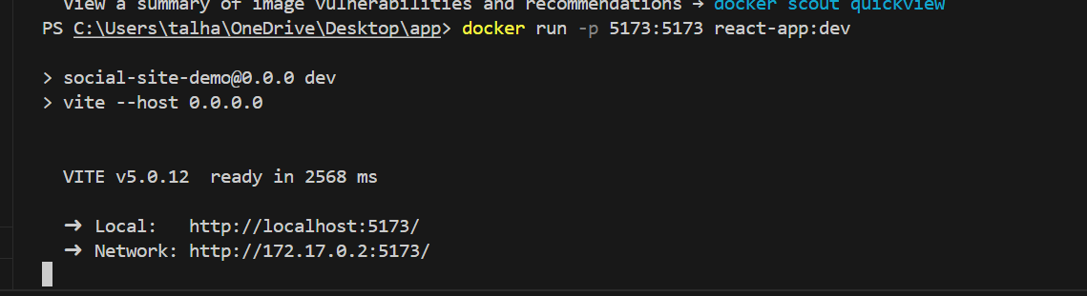
```
- Press Enter to run the command.
- This command will start the Docker container for your React application and expose port 5173 on your local machine.

Access Your React Application:
- Once the Docker container is running, open your web browser.
- In the address bar, type `http://localhost:5173` and press Enter.
- You should see your React application running in the browser.





